**Day2**

1) Alter Table:

* Add a new column linkedin_profile to employees table to store LinkedIn URLs as varchar.

alter table "My Schema".employees

add column linkedin_profile character varying

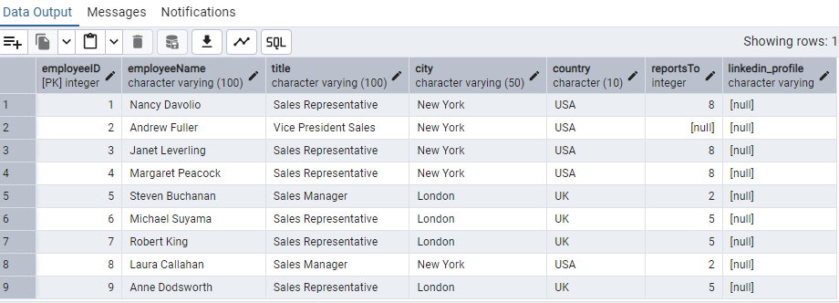

* Change the linkedin_profile column data type from VARCHAR to TEXT.

alter table employees

alter column linkedin_profile TYPE text

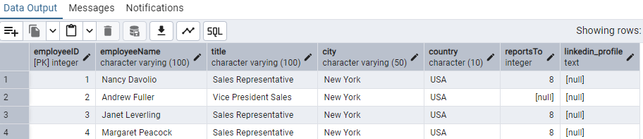

* Add unique, not null constraint to linkedin_profile

------For Not Null Constraint

update employees

set linkedin_profile = 'Missing'

where linkedin_profile is Null

alter table employees

alter column linkedin_profile set not null

-------For unique constraint

update employees

set linkedin_profile = 'Missing_'|| "employeeID"

alter table employees

add constraint unique_profile Unique(linkedin_profile)

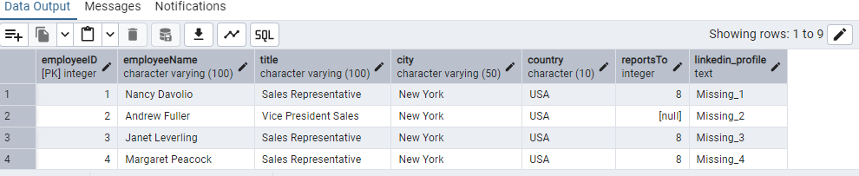

* Drop column linkedin_profile

alter table employees

Drop column linkedin_profile

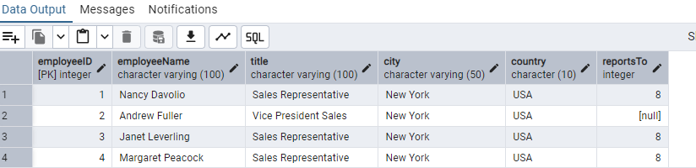

2) Querying (Select)

* Retrieve the first name, last name, and title of all employees

select "employeeName","title" from employees

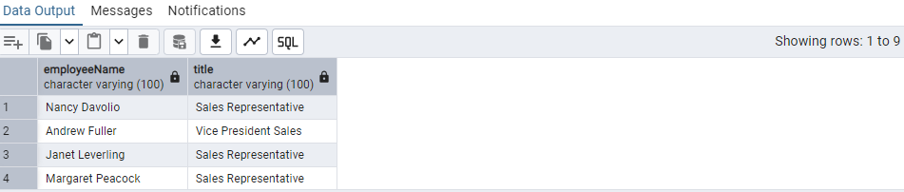

* Find all unique unit prices of products

select distinct "unitPrice" from products

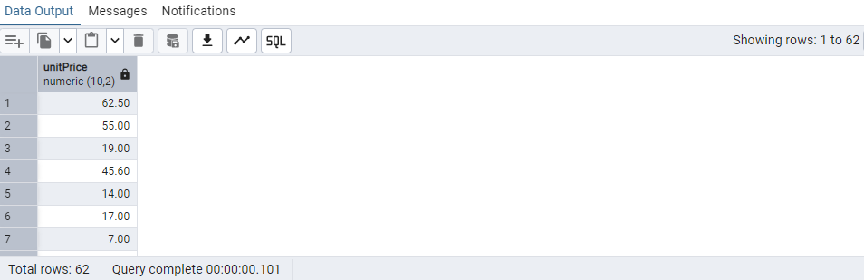

* List all customers sorted by company name in ascending order

select * from customers order by "CompanyName" ASC

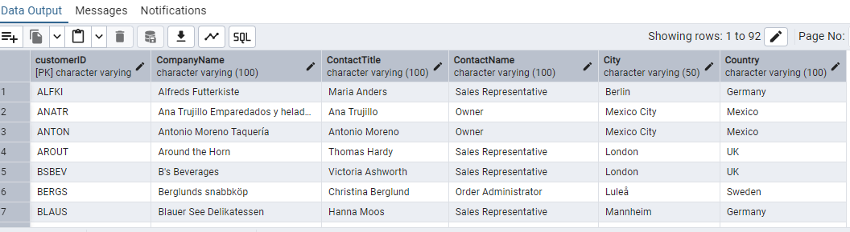

* Display product name and unit price, but rename the unit_price column as price_in_usd

alter table products

rename "unitPrice" to "price_in_usd"

select "productName","price_in_usd" from products

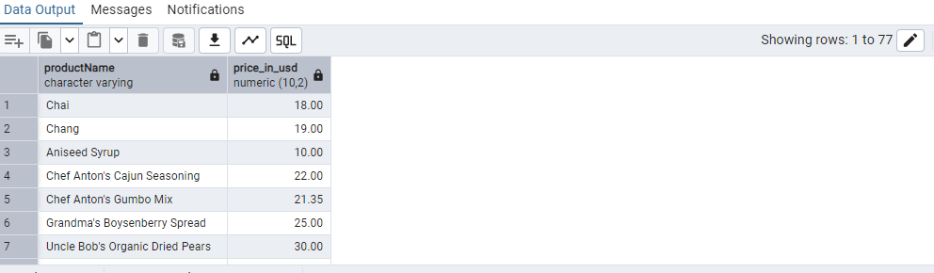

3) Filtering

* Get all customers from Germany.

select "customerID" from customers

where "Country" = 'Germany'

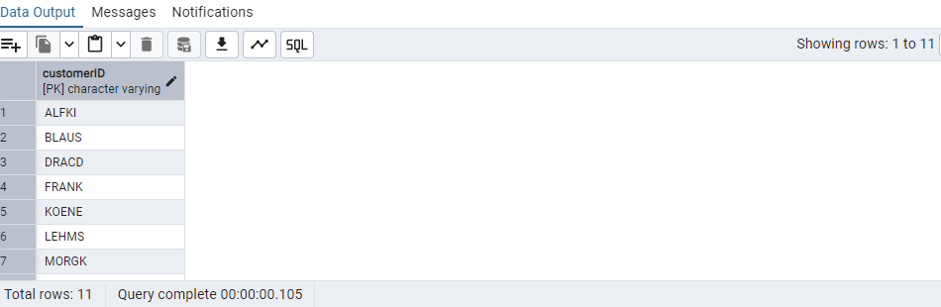

* Find all customers from France or Spain

select * from customers

where "Country" In ('France','Spain')

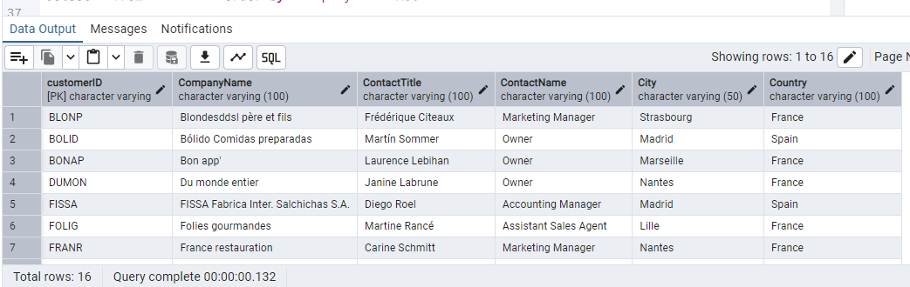

* Retrieve all orders placed in 1997 (based on order_date), and either have freight greater than 50 or the shipped date available (i.e., non-NULL) (Hint: EXTRACT(YEAR FROM order_date))

Select * from orders

Where EXTRACT(YEAR FROM "orderDate") = 2013

AND ("freight" > 50 OR "shippedDate" IS NOT NULL)

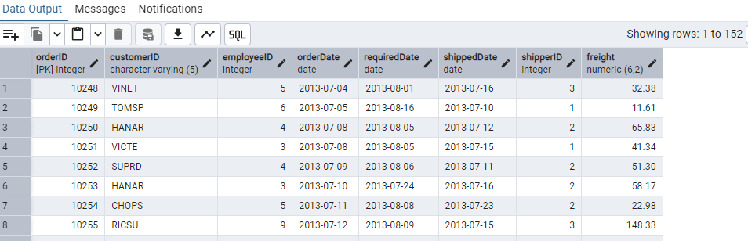

4) Filtering

* Retrieve the product_id, product_name, and unit_price of products where the unit_price is greater than 15.

select "productID","productName","price_in_usd" from products

where ("price_in_usd">15)

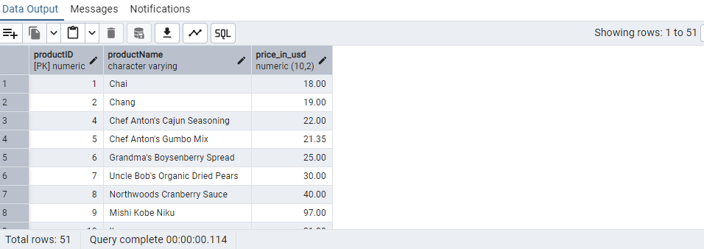

* List all employees who are located in the USA and have the title "Sales Representative".

select * from employees

where("country"='USA' and "title"= 'Sales Representative')

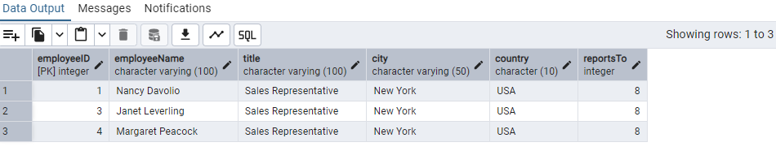

* Retrieve all products that are not discontinued and priced greater than 30.

select * from products

where ("discontinued" = 'false' and "price_in_usd" > 30)

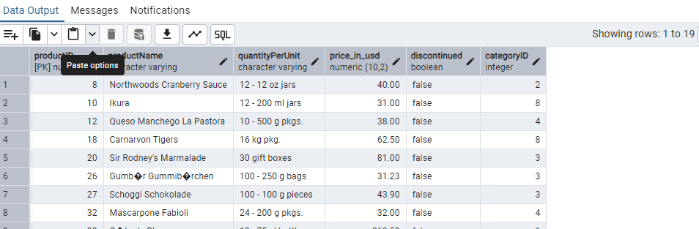

5) LIMIT/FETCH

* Retrieve the first 10 orders from the orders table.

select * from orders limit 10

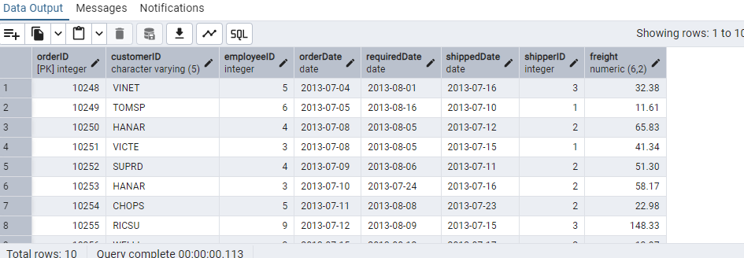

* Retrieve orders starting from the 11th order, fetching 10 rows (i.e., fetch rows 11-20).

select * from orders limit 10 offset 10

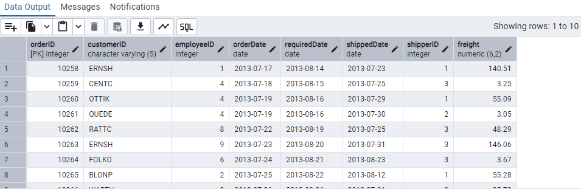

6) Filtering (IN, BETWEEN)

* List all customers who are either Sales Representative, Owner

select * from customers

where "ContactName" in ('Sales Representative','owner')

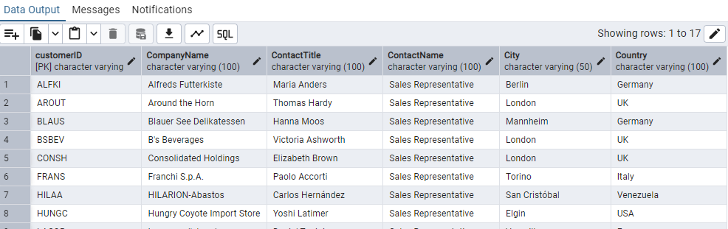

* Retrieve orders placed between January 1, 2013, and December 31, 2013.

select * from orders

where "orderDate" between '2013-01-01' and '2013-12-31'

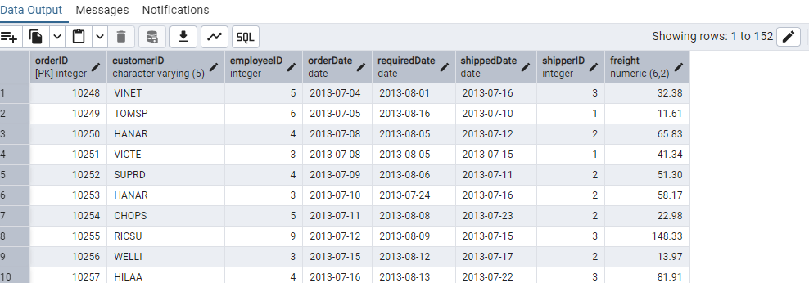

7) Filtering

* List all products whose category_id is not 1, 2, or 3.

select * from products

where "categoryID" not in(1,2,3)

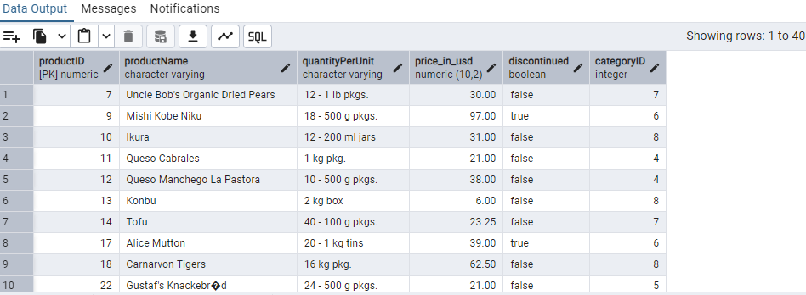

* Find customers whose company name starts with "A".

select * from customers

where "CompanyName" Like 'A%'

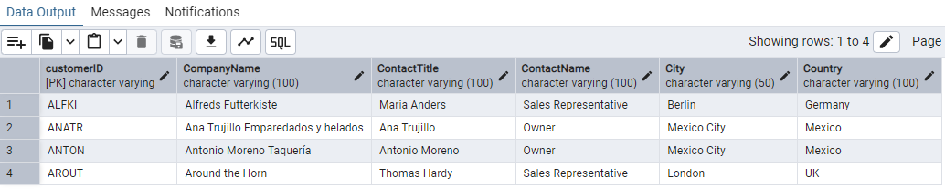

8) INSERT into orders table:

Task: Add a new order to the orders table with the following details:

Order ID: 11078

Customer ID: ALFKI

Employee ID: 5

Order Date: 2025-04-23

Required Date: 2025-04-30

Shipped Date: 2025-04-25

shipperID:2

Freight: 45.50

insert into orders("orderID","customerID","employeeID","orderDate","requiredDate","shippedDate","shipperID","freight")

values(11078,'ALFKI',5,'2025-04-23','2025-04-30','2025-04-25',2,45.50)

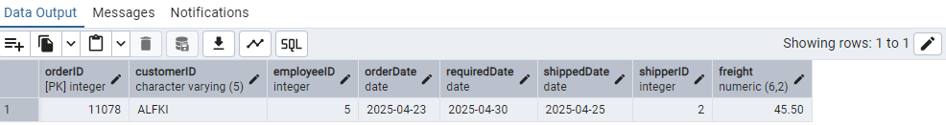

9) Increase(Update) the unit price of all products in category_id =2 by 10%.

(HINT: unit_price =unit_price * 1.10)

Update products

set "price_in_usd" = "price_in_usd" * 1.10

WHERE "categoryid" = 2

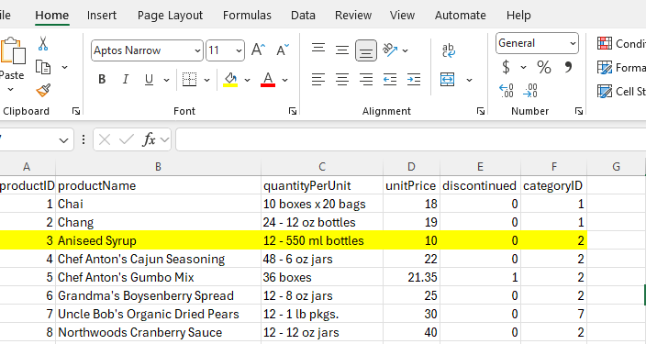

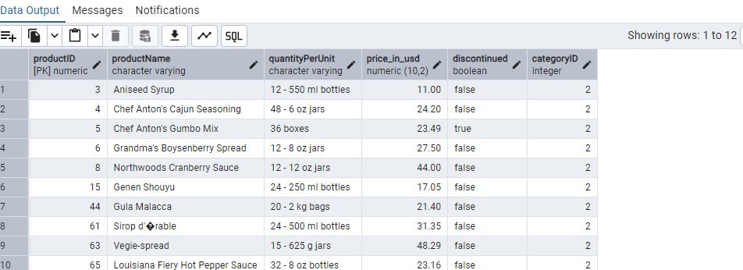

10) Sample Northwind database:

Download

1. Download northwind.sql from below link into your local. Sign in to Git first <https://github.com/pthom/northwind_psql>
2. Manually Create the database using pgAdmin:
   1. Right-click on "Databases" → Create → Database
   2. Give name as ‘northwind’ (all small letters)
   3. Click ‘Save’

Import database:

1. Open pgAdmin and connect to your server
2. Select the database ‘northwind’
3. Right Click-> Query tool.
4. Click the folder icon to open your northwind.sql file
5. Press F5 or click the Execute button.
6. You will see total 14 tables loaded
7. Databases → your database → Schemas → public → Tables

